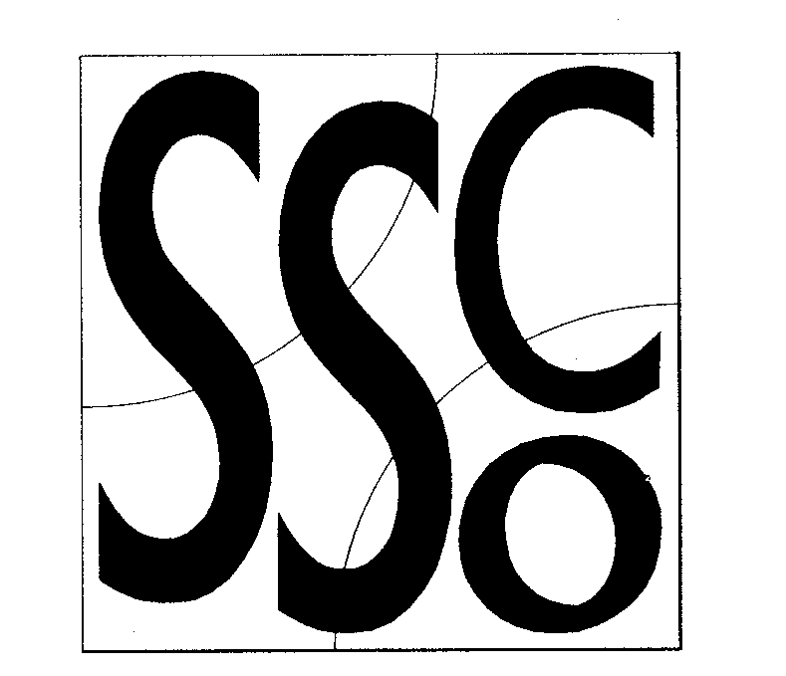

Teaching Points
Always be in control of movements

Swiss Ball Exercises
MULTI SKILL CARDS

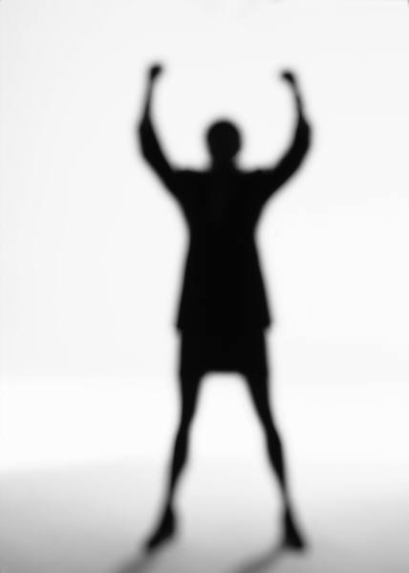

Activity/ Key Points

Stretch a leg and the lateral Stretch the posterior muscles of one leg while keeping the back
muscles of the body straight

Stretch the muscles of the back

